1. Objective of whole project.

Compare MADGE data to other machine learning algorithms like SVM and neural networks. Accuracy and speed will be the two most optimized features, with accuracy without overfitting as the most interesting piece to explore.

1. What was implemented last week.

Trials were conducted to classify STL-10 data. STL-10 data is split into 96 x 96 images in three layers RGB with 10 total classification categories.

Each layer was converted into a 1 x 9216 vector. Standard 80%/20% testing to training data was used.

Classification accuracy was around ~10% for each layer. Combining the layers into one 1 x 27,648 vector also yielded around 10% accuracy.

1. Plans for upcoming week.

Previous datasets had fewer dimensions. The MNIST data set only had a 28 x 28 field, or a 1 x 784. It seems like higher dimensionality could be the limiting factor to MADGE.

I propose a moving window, similar to something like the image below: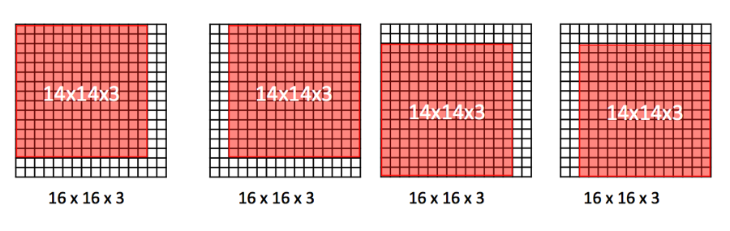

This way a smaller dimensionality is collected and classified.

1. Objective of whole project.

Compare MADGE data to other machine learning algorithms like SVM and neural networks. Accuracy and speed will be the two most optimized features, with accuracy without overfitting as the most interesting piece to explore.

1. What was implemented last week.

Ran accuracy tests on two datasets: abalone and iris petal data.

A cursory glance at accuracies on Iris petal data online match with the highest accuracies. I Will try to find an academic paper that analyzes this dataset. The abalone dataset also had a higher accuracy than found on this paper:

<http://users.cecs.anu.edu.au/~Tom.Gedeon/conf/ABCs2018/paper/ABCs2018_paper_35.pdf>

A runtime comparison should be made between the two methods.

1. Plans for upcoming week.

Write up a paragraph comparing the two methods between the paper found and my work similar to how it would be written in a paper.

Find another dataset and literature that can show our method is superior.